Министерство науки и высшего образования Российской Федерации
Муромский институт (филиал)
Федерального государственного бюджетного образовательного учреждения высшего образования
«Владимирский государственный университет
имени Александра Григорьевича и Николая Григорьевича Столетовых»

Факультет ИТР
Кафедра ПИн

ЛАБОРАТОРНАЯ
РАБОТА №3

По Проектирование человеко-машинного интерфейса
Тема Создание горячих клавиш в WPF приложениях

Руководитель
Каряев В.В.
(фамилия, инициалы)

(подпись) (дата)

Студент ПИн - 121
(группа)
Ермилов М.В.
(фамилия, инициалы)

(подпись) (дата)

Муром 2023
Лабораторная работа №3

Тема: Создание горячих клавиш в WPF приложениях.
Цель: Научится создавать горячие клавиши в WPF приложениях.
Задание:
1. Изучить материал, представленный в данных методических указаниях к лабораторной работе; 2. Разработать WPF приложение, согласно заданию преподавателя; 3. Составить отчет. В отчете отобразить:  -цели и задачи лабораторной работы;  -XAML разметку;  -исходный код приложения (отображающий только логику программы и описание файлов ресурсов);  -скриншоты работы приложения;  -выводы по проделанной лабораторной работе..

Листинг программы:
<Window x:Class="work.test"
xmlns="http://schemas.microsoft.com/winfx/2006/xaml/presentation"
xmlns:x="http://schemas.microsoft.com/winfx/2006/xaml"
Title="ShortKey" MinHeight="78" MinWidth="270" MaxHeight="78" MaxWidth="270">
<Window.Resources>
<RoutedUICommand x:Key="First" Text="First" />
<RoutedUICommand x:Key="Second" Text="Second" />
<RoutedUICommand x:Key="Third" Text="Third" />
</Window.Resources>
<Window.CommandBindings>
<CommandBinding Command="{StaticResource First}" Executed="One" />
<CommandBinding Command="{StaticResource Second}" Executed="Two" />
<CommandBinding Command="{StaticResource Third}" Executed="Three" />
</Window.CommandBindings>
<Window.InputBindings>
<KeyBinding Key="Q" Modifiers="Ctrl" Command="{StaticResource First}" />
<KeyBinding Key="W" Modifiers="Ctrl+Alt" Command="{StaticResource Second}" />
<KeyBinding Key="E" Modifiers="Shift" Command="{StaticResource Third}" />
</Window.InputBindings>

<Grid>
<Button x:Name="bOne"
Margin="10,10,0,0"
Height="25"
Width="75"
HorizontalAlignment="Left"
VerticalAlignment="Top"
Content="Раз"
Command="{DynamicResource First}" />
<Button x:Name="bTwo"
Margin="90,10,0,0"
Height="25"
Width="75"
HorizontalAlignment="Left"
VerticalAlignment="Top"
Content="Два"
Command="{DynamicResource Second}" />
<Button x:Name="bThree"
Margin="170,10,0,0"
Height="25"
Width="75"
HorizontalAlignment="Left"
VerticalAlignment="Top"
Content="Три"
Command="{DynamicResource Third}" />
</Grid>
</Window>

using System.Windows;
using System.Windows.Input;

namespace work
{
public partial class test : Window
{
public test()
{
InitializeComponent();
}
private void One(object sender, ExecutedRoutedEventArgs e)
{
MessageBox.Show("Вы нажали \'Ctrl+Q\'");
}
private void Two(object sender, ExecutedRoutedEventArgs e)
{
MessageBox.Show("Вы нажали \'Ctrl+Alt+W\'");
}
private void Three(object sender, ExecutedRoutedEventArgs e)
{
MessageBox.Show("Вы нажали \'Shift+E\'");
}

}
}
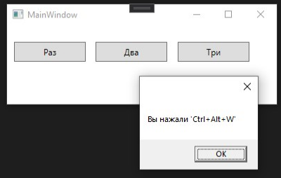
Рисунок 1 - пример работы

Листинг программы:
<Window x:Class="LB3.MainWindow"
xmlns="http://schemas.microsoft.com/winfx/2006/xaml/presentation"
xmlns:x="http://schemas.microsoft.com/winfx/2006/xaml"
xmlns:d="http://schemas.microsoft.com/expression/blend/2008"
xmlns:mc="http://schemas.openxmlformats.org/markup-compatibility/2006"
xmlns:local="clr-namespace:LB3"
mc:Ignorable="d"
Title="Учёт данных студентов" Height="342" Width="525">
<Window.Resources>
<RoutedUICommand x:Key="Add" Text="Add"/>
<RoutedUICommand x:Key="Change" Text="Change"/>
<RoutedUICommand x:Key="Delete" Text="Delete"/>
</Window.Resources>
<Window.CommandBindings>
<CommandBinding Command="{StaticResource Add}" Executed="Add" />
<CommandBinding Command="{StaticResource Change}" Executed="Change" />
<CommandBinding Command="{StaticResource Delete}" Executed="Delete" />
</Window.CommandBindings>
<Window.InputBindings>
<KeyBinding Key="A" Modifiers="Ctrl" Command="{StaticResource Add}" />
<KeyBinding Key="E" Modifiers="Ctrl" Command="{StaticResource Change}" />
<KeyBinding Key="X" Modifiers="Ctrl" Command="{StaticResource Delete}" />
</Window.InputBindings>
<Grid HorizontalAlignment="Center" VerticalAlignment="Center">
<DataGrid x:Name="Students" HorizontalAlignment="Left" Height="243" Margin="10,10,0,0" VerticalAlignment="Top" Width="470" IsReadOnly="True" SelectionMode="Single"/>
<Button Content="Добавить" HorizontalAlignment="Left" Height="21" Margin="10,266,0,0" VerticalAlignment="Top" Width="96" Click="Add"/>
<Button Content="Изменить" HorizontalAlignment="Left" Height="21" Margin="121,266,0,0" VerticalAlignment="Top" Width="96" Click="Change"/>
<Button Content="Удалить запись" HorizontalAlignment="Left" Height="22" Margin="383,265,0,0" VerticalAlignment="Top" Width="97" Click="Delete"/>
</Grid>
</Window>

<Window x:Class="LB3.WindowStudent"
xmlns="http://schemas.microsoft.com/winfx/2006/xaml/presentation"
xmlns:x="http://schemas.microsoft.com/winfx/2006/xaml"
xmlns:d="http://schemas.microsoft.com/expression/blend/2008"
xmlns:mc="http://schemas.openxmlformats.org/markup-compatibility/2006"
xmlns:local="clr-namespace:LB3"
mc:Ignorable="d"
Title="Данные студента" MinHeight="443.937" MinWidth="292" MaxHeight="443.937" MaxWidth="292">
<Window.Resources>
<RoutedUICommand x:Key="Save" Text="Save"/>
<RoutedUICommand x:Key="Clear" Text="Clear"/>
<RoutedUICommand x:Key="Cancel" Text="Cancel"/>
</Window.Resources>
<Window.CommandBindings>
<CommandBinding Command="{StaticResource Save}" Executed="Save" />
<CommandBinding Command="{StaticResource Clear}" Executed="Clear" />
<CommandBinding Command="{StaticResource Cancel}" Executed="Cancel" />
</Window.CommandBindings>
<Window.InputBindings>
<KeyBinding Key="S" Modifiers="Ctrl" Command="{StaticResource Save}" />
<KeyBinding Key="X" Modifiers="Ctrl+Alt" Command="{StaticResource Clear}" />
<KeyBinding Key="Q" Modifiers="Ctrl" Command="{StaticResource Cancel}" />
</Window.InputBindings>
<Grid>
<Label Content="Фамилия" HorizontalAlignment="Left" Height="27" Margin="18,10,0,0" VerticalAlignment="Top" Width="65"/>
<TextBox x:Name="InputSurname" HorizontalAlignment="Left" Height="27" Margin="24,37,0,0" TextWrapping="Wrap" VerticalAlignment="Top" Width="234"/>
<Label Content="Имя" HorizontalAlignment="Left" Height="27" Margin="18,64,0,0" VerticalAlignment="Top" Width="65"/>
<TextBox x:Name="InputName" HorizontalAlignment="Left" Height="27" Margin="24,91,0,0" TextWrapping="Wrap" VerticalAlignment="Top" Width="234"/>
<Label Content="Отчество" HorizontalAlignment="Left" Height="27" Margin="18,118,0,0" VerticalAlignment="Top" Width="65"/>
<TextBox x:Name="InputPatronymic" HorizontalAlignment="Left" Height="27" Margin="24,145,0,0" TextWrapping="Wrap" VerticalAlignment="Top" Width="234"/>
<Label Content="Факультет" HorizontalAlignment="Left" Height="27" Margin="18,172,0,0" VerticalAlignment="Top" Width="65"/>
<TextBox x:Name="InputFaculty" HorizontalAlignment="Left" Height="27" Margin="24,201,0,0" TextWrapping="Wrap" VerticalAlignment="Top" Width="234"/>
<Label Content="Группа" HorizontalAlignment="Left" Height="27" Margin="18,226,0,0" VerticalAlignment="Top" Width="65"/>
<TextBox x:Name="InputGroup" HorizontalAlignment="Left" Height="27" Margin="24,253,0,0" TextWrapping="Wrap" VerticalAlignment="Top" Width="234"/>
<Label Content="Дата рождения" HorizontalAlignment="Left" Height="27" Margin="19,280,0,0" VerticalAlignment="Top" Width="101"/>
<DatePicker x:Name="InputDateBirth" HorizontalAlignment="Left" Height="28" Margin="24,307,0,0" VerticalAlignment="Top" Width="234"/>
<Button Content="Сохранить" HorizontalAlignment="Left" Height="21" Margin="24,374,0,0" VerticalAlignment="Top" Width="79" Click="Save"/>
<Button Content="Очистить все" HorizontalAlignment="Left" Height="21" Margin="179,340,0,0" VerticalAlignment="Top" Width="79" Click="Clear"/>
<Button Content="Отменить" HorizontalAlignment="Left" Height="21" Margin="179,374,0,0" VerticalAlignment="Top" Width="79" Click="Cancel"/>
</Grid>
</Window>

using System.Collections.Generic;
using System.Windows;
using System.Windows.Controls;

namespace LB3
{
public partial class MainWindow : Window
{
public List<Student> students = new List<Student>();
public MainWindow()
{
InitializeComponent();
Students.ItemsSource = students;
}
private void Add(object sender, RoutedEventArgs e)
{
WindowStudent window = new WindowStudent();
if(window.ShowDialog() == true)
{
students.Add(window.student);
Students.Items.Refresh();
}
}

private void Change(object sender, RoutedEventArgs e)
{
if(Students.SelectedIndex >= 0 && students.Count < Students.SelectedIndex)
{
WindowStudent window = new WindowStudent(students[Students.SelectedIndex]);
if (window.ShowDialog() == true)
{
students[Students.SelectedIndex] = window.student;
Students.Items.Refresh();
}
}
}

private void Delete(object sender, RoutedEventArgs e)
{
if (Students.SelectedIndex >= 0 && students.Count < Students.SelectedIndex)
{
students.Remove(students[Students.SelectedIndex]);
Students.Items.Refresh();
}
}
}
}

using System.Windows;

namespace LB3
{
public partial class WindowStudent : Window
{
public Student student = new Student();
public WindowStudent() => InitializeComponent();

public WindowStudent(Student student):this()
{
InputSurname.Text = student.Surname;
InputName.Text = student.Name;
InputPatronymic.Text = student.Patronymic;
InputFaculty.Text = student.Faculty;
InputGroup.Text = student.Group;
InputDateBirth.Text = student.DateBirth;
}

private void Save(object sender, RoutedEventArgs e)
{
if(
InputSurname.Text.Trim() == "" ||
InputName.Text.Trim() == "" ||
InputPatronymic.Text.Trim() == "" ||
InputFaculty.Text.Trim() == "" ||
InputGroup.Text.Trim() == "" ||
InputDateBirth.Text == null)
{
MessageBox.Show("Введите все данные!");
return;
}
student.Name = InputName.Text.Trim();
student.Surname = InputSurname.Text.Trim();
student.Patronymic = InputPatronymic.Text.Trim();
student.Faculty = InputFaculty.Text.Trim();
student.Group = InputGroup.Text.Trim();
student.DateBirth = InputDateBirth.Text;
DialogResult = true;
}

private void Cancel(object sender, RoutedEventArgs e) => DialogResult = false;
private void Clear(object sender, RoutedEventArgs e)
{
InputSurname.Clear();
InputName.Clear();
InputPatronymic.Clear();
InputFaculty.Clear();
InputGroup.Clear();
InputDateBirth.Text = null;
}
}
}

namespace LB3
{
public class Student
{
public string Name { get; set; }
public string Surname { get; set; }
public string Patronymic { get; set; }
public string Faculty { get; set; }
public string Group { get; set; }
public string DateBirth { get; set; }
}

}
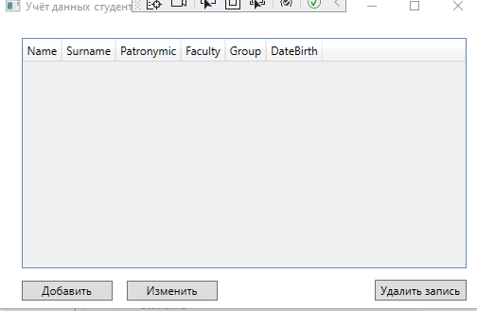
Рисунок 2 - пример работы программы.

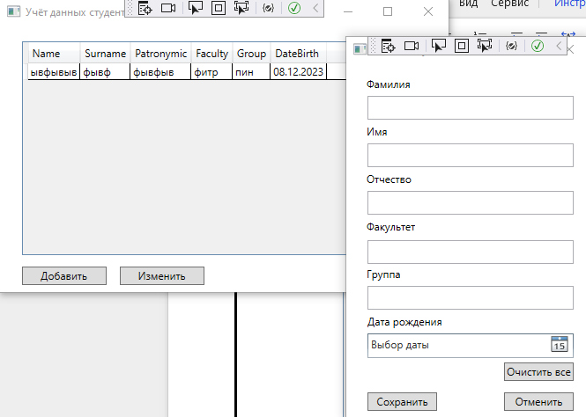
Рисунок 3 - пример работы программы.

Вывод: в ходе работы были изучены методы создания горячих клавиш.

